PyCharm *installation* in Windows

Contents

1. Download PyCharm 2

2. Installation of PyCharm 2

Choose Install Location 3

Installation Options 3

3. Error(s) during installation: 5

4. Working with PyCharm 6

## Download PyCharm

Download the PyCharm Community version for windows environment: <https://www.jetbrains.com/pycharm/download/#section=windows>

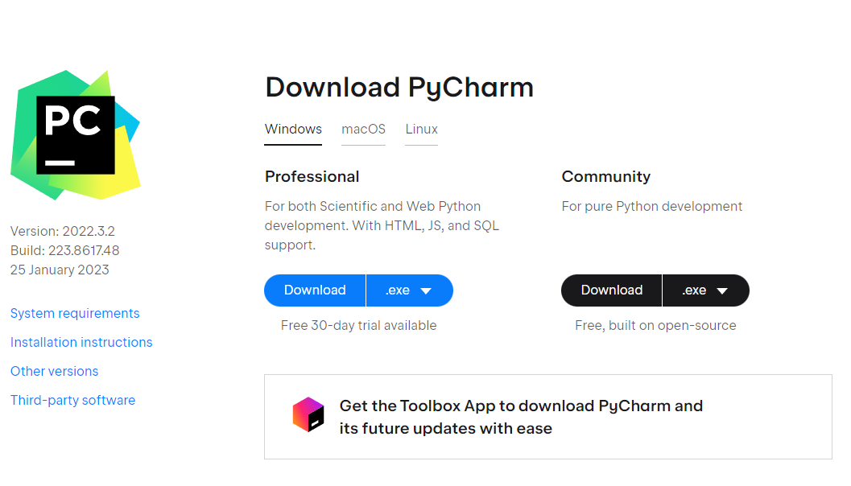

**Note:** Installation in Mac is not that different, as the installable will be (.dmg) instead of a (.exe) file.

## Installation of PyCharm

Install the PyCharm by double-clicking the .exe file. Click “**Next**”

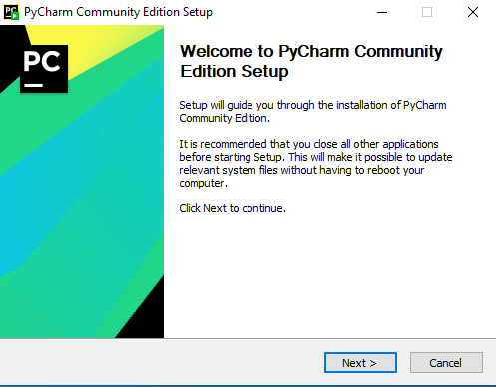

### Choose Install Location

Select the file-path where PyCharm should be installed, I usually prefer installing these packages under “**C:\Users\NXI220005\installation_packages\PyCharm**”, however this can be ignored and one can prefer to click “**Next**”.

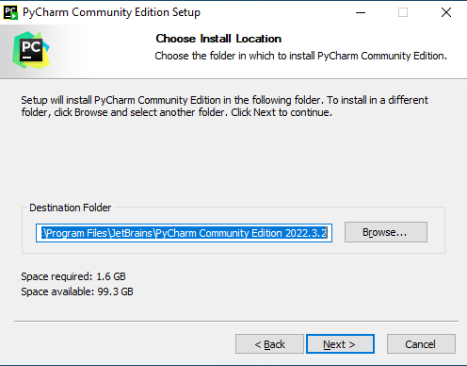

### Installation Options

Here by checking the below-mentioned boxes, ***PyCharm desktop shortcut*** and the bin folder gets ***added*** to the **PATH**. One can choose to skip these steps too, as PyCharm can be accessed from the application pane. Click “**Next**”.

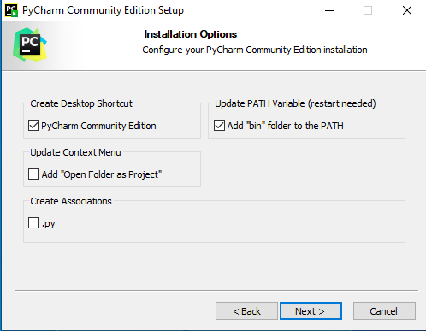

Click “**Install**”

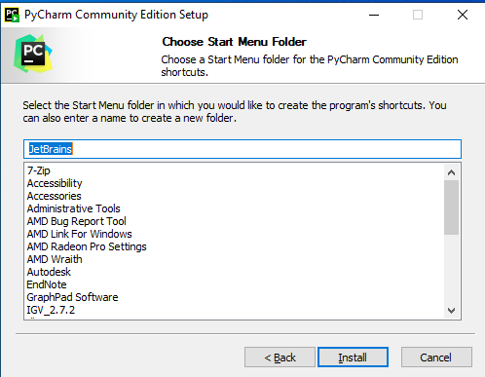

Once installation is completed, click on “**Finish**”.

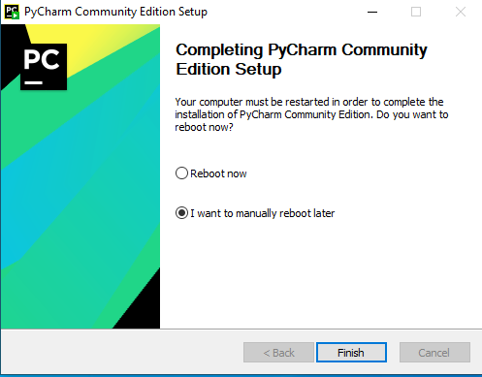

## Error(s) during installation:

Not all users have access to \**ProgramFiles**\ readily, some users may need elevated permission to perform installation systemwide of for the same user in restricted folder(s). Hence, I used “ C:\Users\NXI220005\installation_packages\PyCharm” directory for my installation.

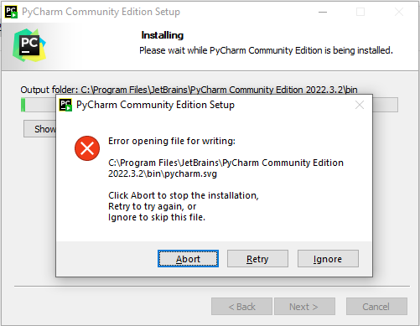

## Working with PyCharm

Once the installation is completed successfully, open PyCharm using the shortcut created during the installation, or open it from the application pane.

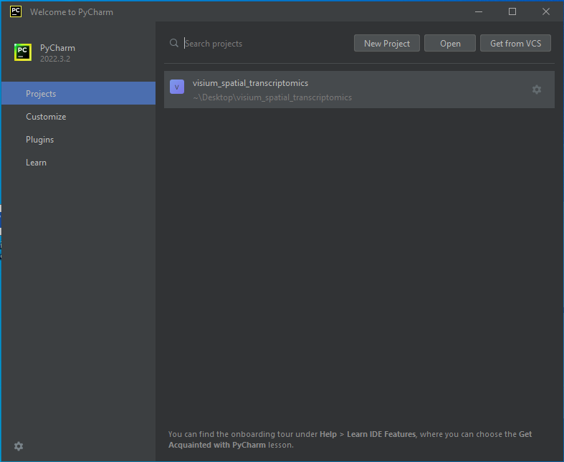

From this screen we should be able to open up the project(s) by clicking on “**Open**” and selecting the project under any folder path; In my case the project is saved under \Desktop so I will be navigating to the project and open it;

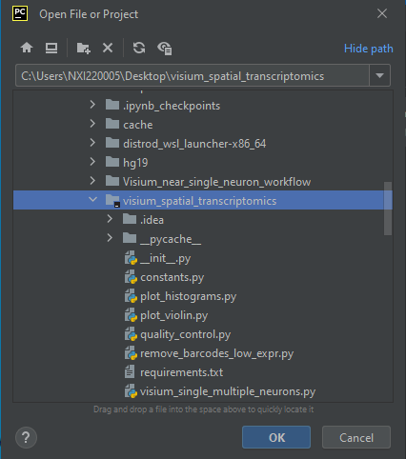

Once the projects opens up, it looks like; At this point we need to setup a python interpreter

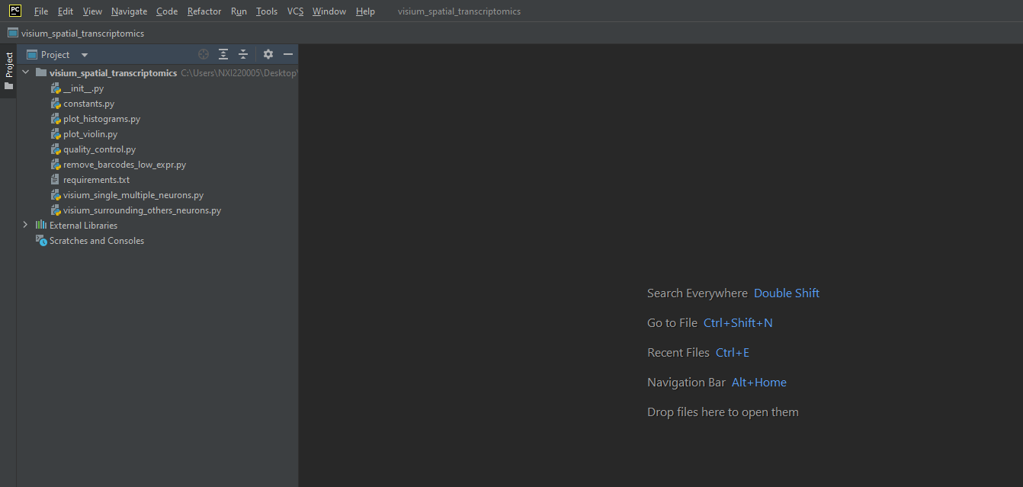

In order to setup a python interpreter to this project, once needs to have python installed on their machines (preferably python3).

At the bottom right corner one can add a python interpreter by clicking on, “**Add New Interpreter**”. Or this can also be accessed from **Files>Settings**.

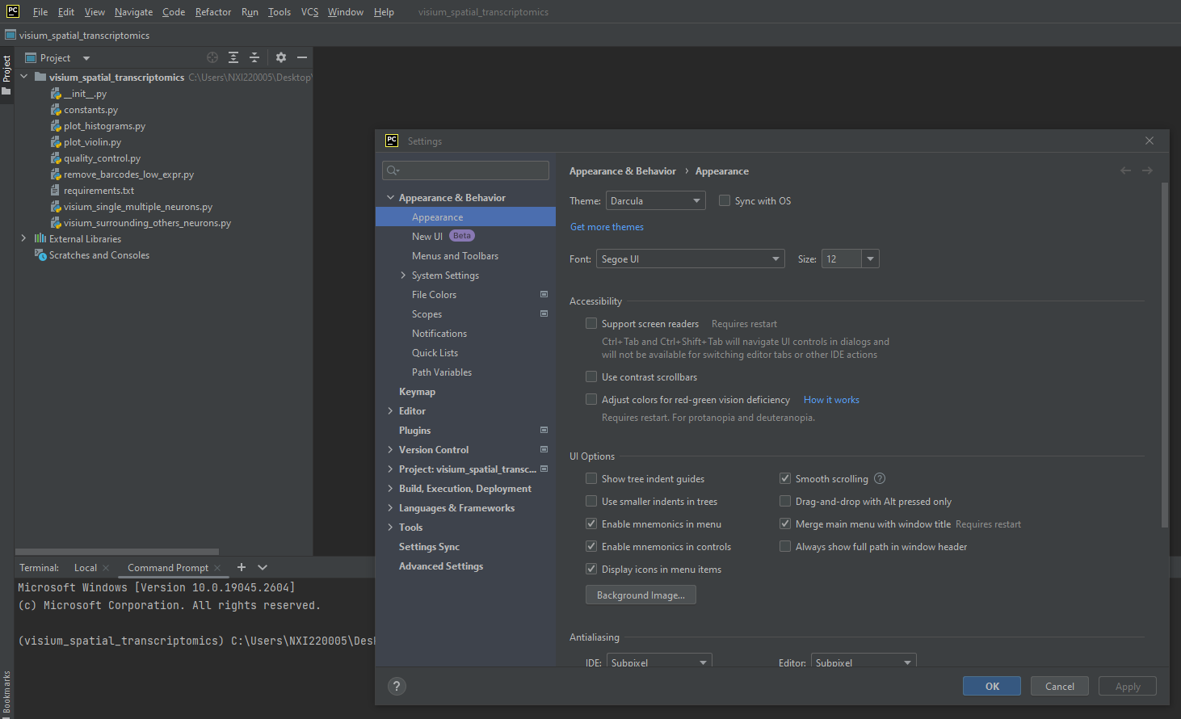

Click on the “**Python Interpreter**”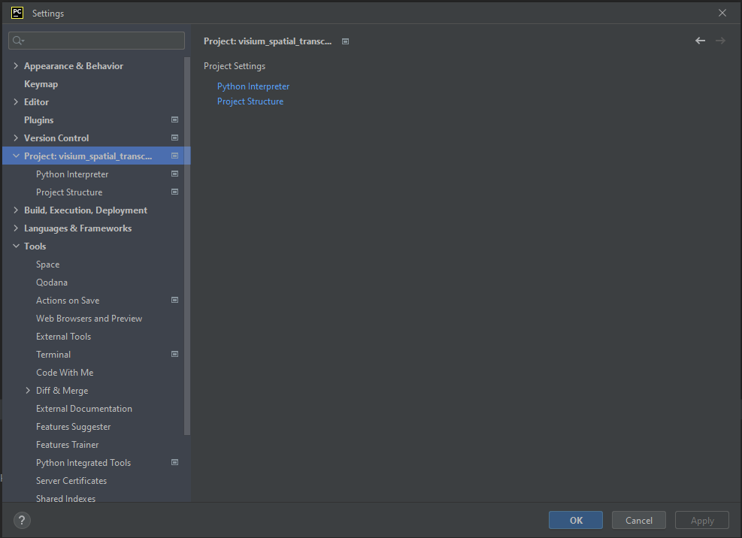

Now **Add interpreter**

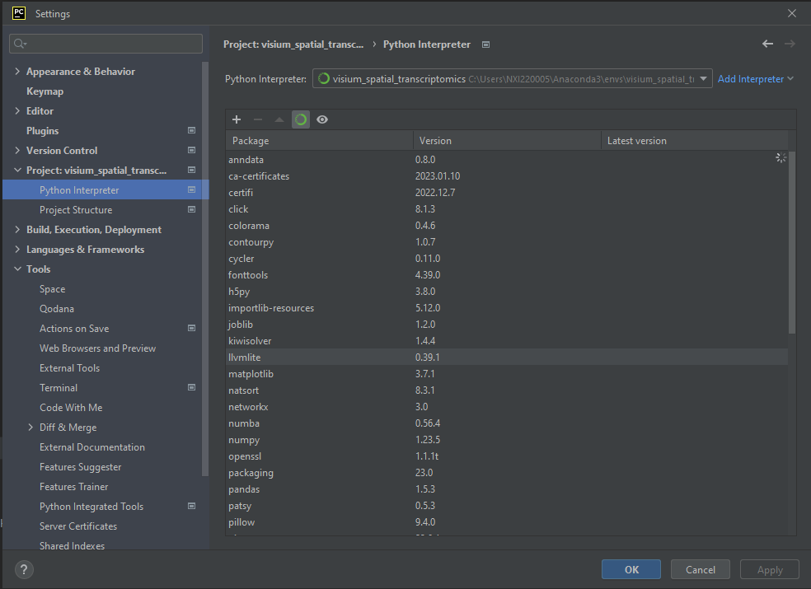

Interpreter can be added from a local installation or from any of the below-listed resources. However, the environment name should be set, as you can see I have named my environment as “**venv**”; 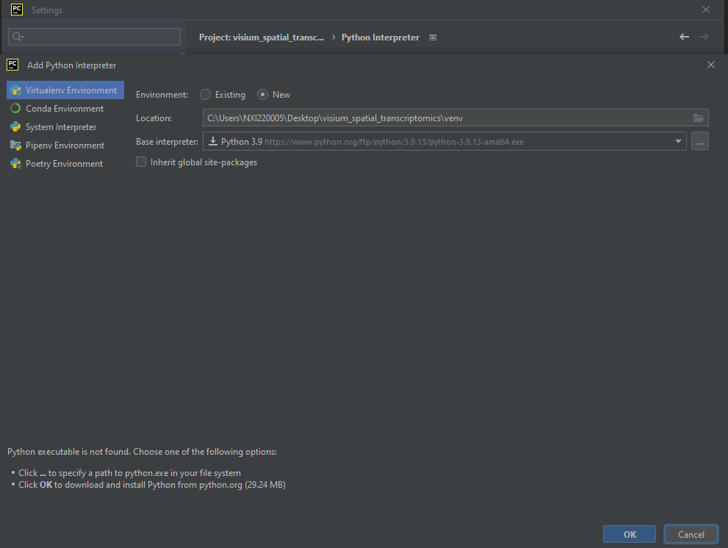

Now that all the things are setup, python scripts can be run using this environment.

The End